|  |  |
| --- | --- |
| Nama | : Afina Putri Dayanti |
| NIM | : 825200049 |
| Jurusan | : Sistem Informasi |
| Mata Kuliah | : UTS Database Design and Management (Practice) |

|  |
| --- |
| --no 1  create or replace function temperature(data_temp in number, data_char in char)  return number is  v_result number(6,1);    begin  if data_char = 'C' or data_char = 'c' then  v_result := 5/9 * (data_temp - 32);  elsif data_char = 'F' or data_char = 'f' then  v_result := (9/5 * data_temp) + 32;  end if;  return v_result;  end;  /  declare  v_temp number := '&temp';  v_char char := '&char';  v_result number;  begin  v_result := temperature(v_temp,v_char);  if v_char = 'C' or v_char = 'c' then  dbms_output.put_line('Konversi dari Fahrenheit ke Celcius');  dbms_output.put_line(v_temp || ' F' || ' = ' || v_result || ' C');  elsif v_char = 'F' or v_char = 'f' then  dbms_output.put_line('Konversi dari Celcius ke Fahrenheit');  dbms_output.put_line(v_temp || ' C' || ' = ' || v_result || ' F');  else  dbms_output.put_line('You entered the wrong code');  end if;  end; |

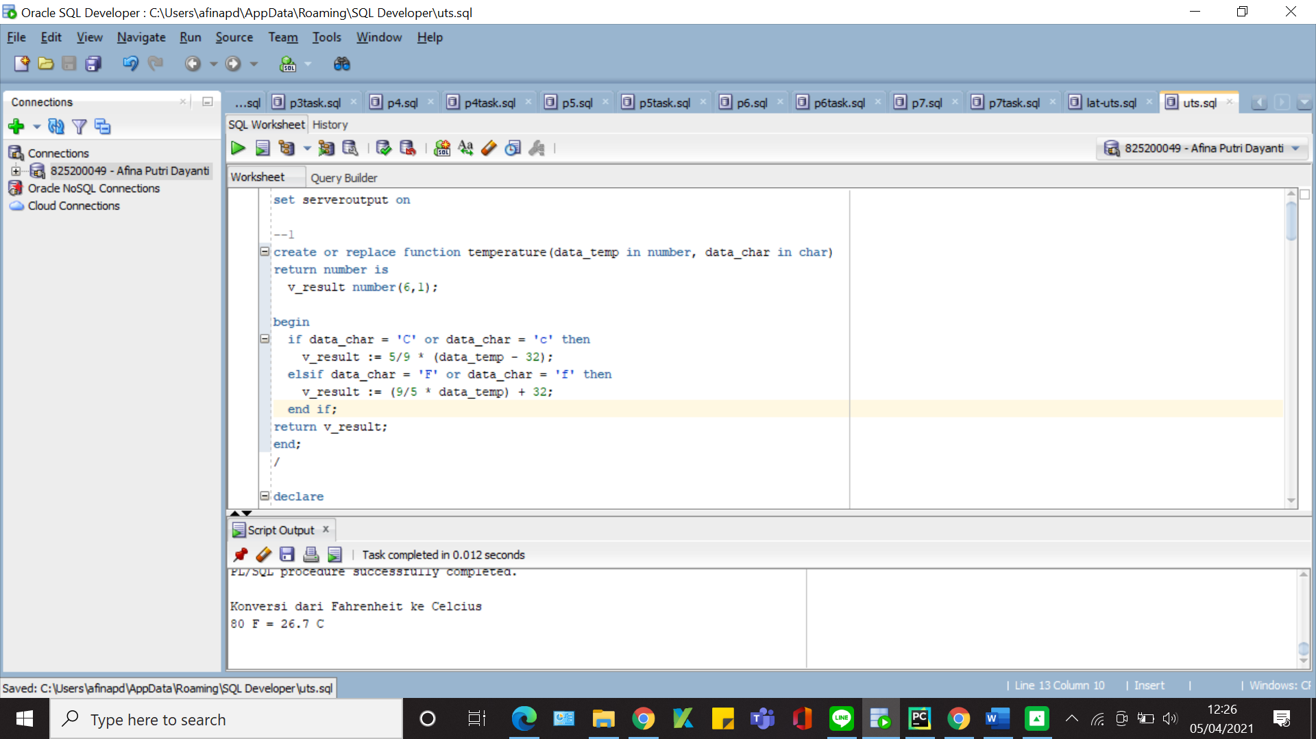

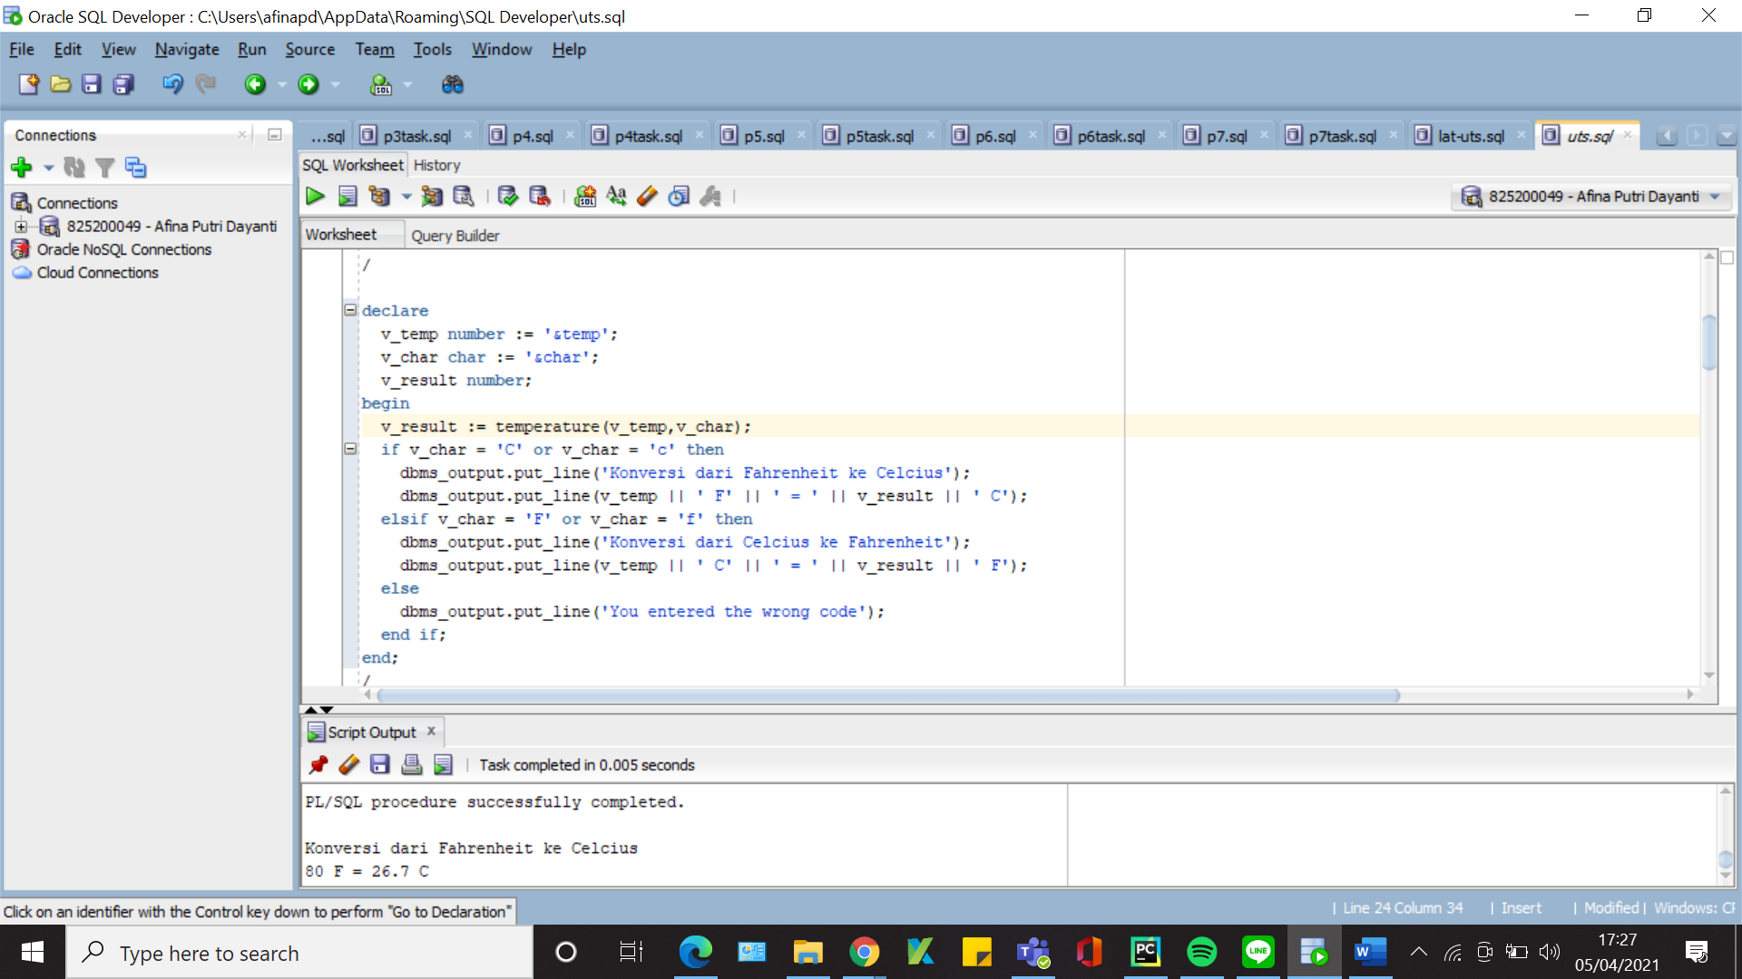

|  |
| --- |
| --no 2  declare  cursor cur_depts_locs is  select d.department_name, d.location_id, l.street_address, l.city  from departments d join locations l  on d.location_id = l.location_id;  v_cur_depts_locs cur_depts_locs%rowtype;  begin  open cur_depts_locs;  loop  fetch cur_depts_locs into v_cur_depts_locs;  exit when cur_depts_locs%notfound;  dbms_output.put_line(v_cur_depts_locs.department_name || ' - ' || v_cur_depts_locs.location_id || ' - ' || v_cur_depts_locs.street_address || ' - ' || v_cur_depts_locs.city);  end loop;  close cur_depts_locs;  end; |

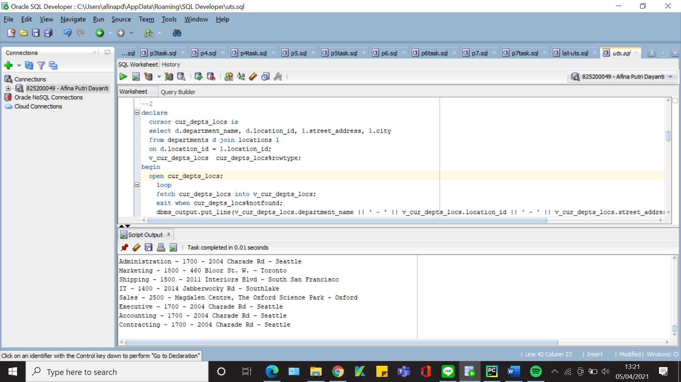

|  |
| --- |
| --no 3  declare  v_last_name employees.last_name%type;  v_salary employees.salary%type;  v_new_salary employees.salary%type;  begin  select last_name, salary into v_last_name, v_salary  from employees  where employee_id = '&x';  if v_salary < 10000 then  v_new_salary := v_salary + (v_salary * 0.20);  dbms_output.put_line('Last Name is ' || v_last_name || ' with salary ' || v_salary || ' and new salary is ' || v_new_salary);  elsif v_salary < 15000 then  v_new_salary := v_salary + (v_salary * 0.10);  dbms_output.put_line('Last Name is ' || v_last_name || ' with salary ' || v_salary || ' and new salary is ' || v_new_salary);  else  v_new_salary := v_salary;  dbms_output.put_line('Last Name is ' || v_last_name || ' cant get additional salary because her/his salary is ' || v_new_salary);  end if;  end; |

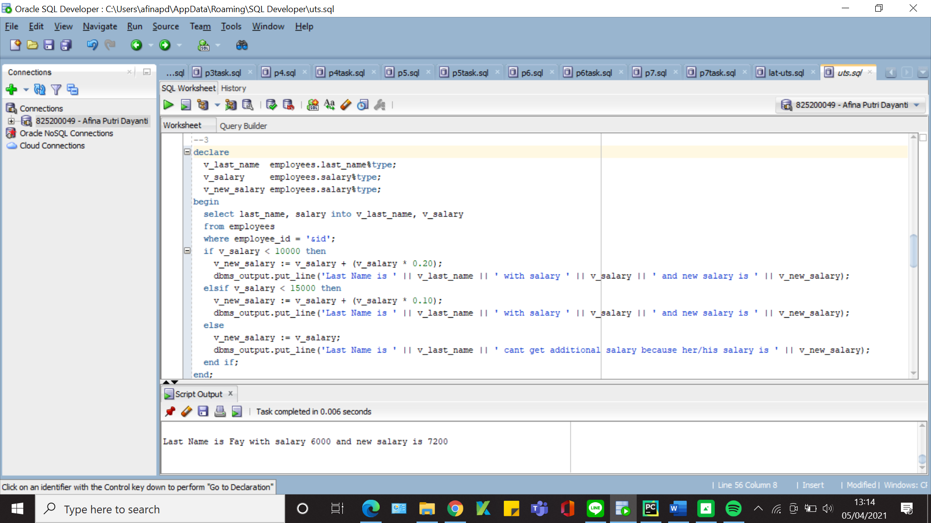

|  |
| --- |
| --no 4  declare  cursor cur_hr is  select d.department_name, count(*) as count  from hr.employees e join hr.departments d  on e.department_id = d.department_id  group by d.department_name  having count(*) > 10;  v_cur_hr cur_hr%rowtype;  begin  open cur_hr;  dbms_output.put_line('Department dengan jumlah karyawan > 10');  loop  fetch cur_hr into v_cur_hr;  exit when cur_hr%notfound;  dbms_output.put_line('Department : '|| v_cur_hr.department_name||', jumlah karyawan : '|| v_cur_hr.count);  end loop;  close cur_hr;  end; |

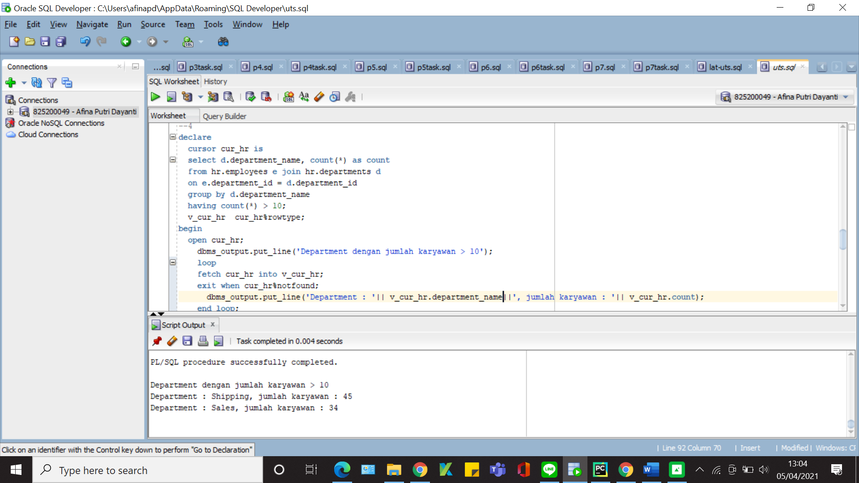

|  |
| --- |
| --no 5  declare  cursor cur_jobs is  select j.job_title as job_title, max(e.salary) as max_salary, min(e.salary) as min_salary, avg(e.salary) as avg_salary  from employees e join jobs j  on e.job_id = j.job_id  where e.job_id = '&job'  group by j.job_title;  begin  for v_jobs_record in cur_jobs  loop  dbms_output.put_line('Job Title : ' || v_jobs_record.job_title);  dbms_output.put_line('Gaji Tertinggi : ' || v_jobs_record.max_salary);  dbms_output.put_line('Gaji Terendah : ' || v_jobs_record.min_salary);  dbms_output.put_line('Gaji Rerata : ' || v_jobs_record.avg_salary);  end loop;  end; |

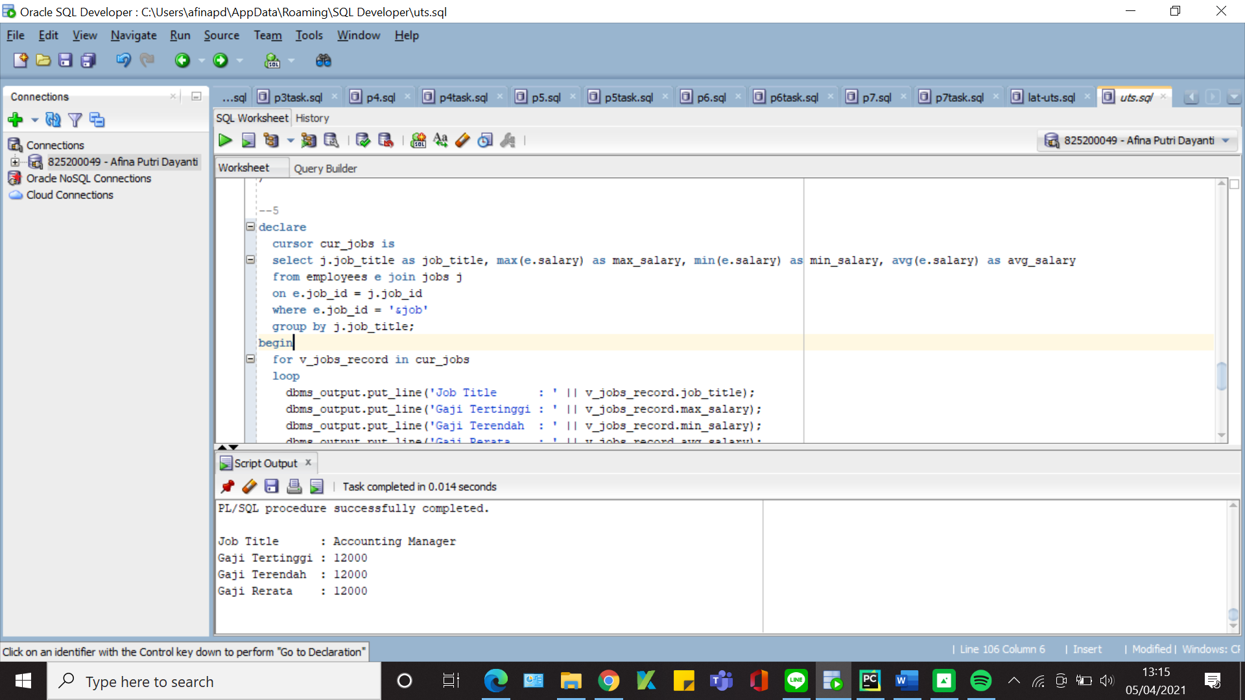

|  |
| --- |
| --no 6  declare  v_first number := '&first';  v_last number := '&last';  v_ganjil number := 0;  v_genap number := 0;  begin  for i in v_first..v_last loop  if mod(i, 2) = 0 then  v_genap := v_genap + 1;  else  v_ganjil := v_ganjil + 1;  end if;  end loop;  dbms_output.put_line('Diantara bilangan ' || v_first || ' dan ' || v_last);  dbms_output.put_line('Jumlah bilangan Ganjil adalah : ' || v_ganjil);  dbms_output.put_line('Jumlah bilangan Genap adalah : ' || v_genap);  end; |

